Juniper Trails Bed and Breakfast

Website Copy

Notes:
- Needs to be clean and simple, easy to navigate
- Must be mobile (vertical aspect) friendly (vertical aspect is important...) as well as horizontal for ipads, laptops, etc

Home Section
_____________________________________________________________________________________________
Reserve Juniper Trails Bed and Breakfast About Rooms Contact

Adventures Rest Stop

Discover Juniper Trails Bed and Breakfast in Williams Lake. Unwind and
enjoy the relaxing ambience and high quality accommodations.

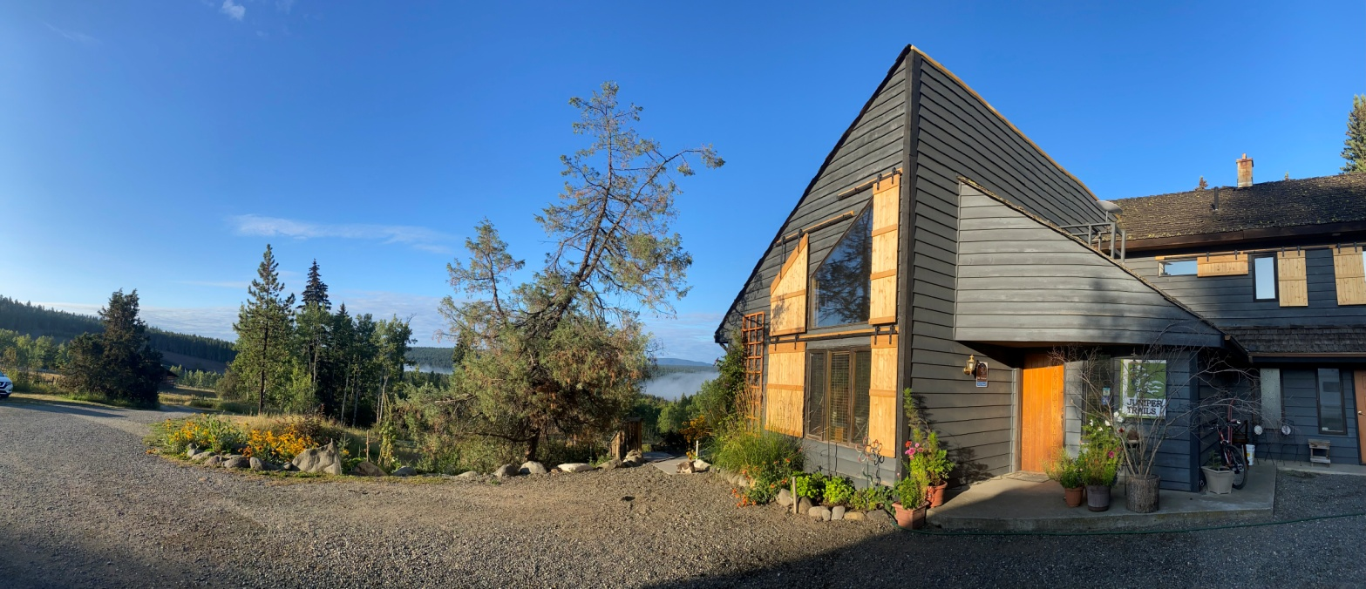

Main Images Gallery
(scroll through, right to left, 5 full width images)

_____________________________________________________________________________________________
About Section

- Short description of property, stay longer, animals, art... with accompanying images

_____________________________________________________________________________________________

27 stunning acres of Cariboo stillness, friendly animals, and thoughtful, welcoming hospitality...

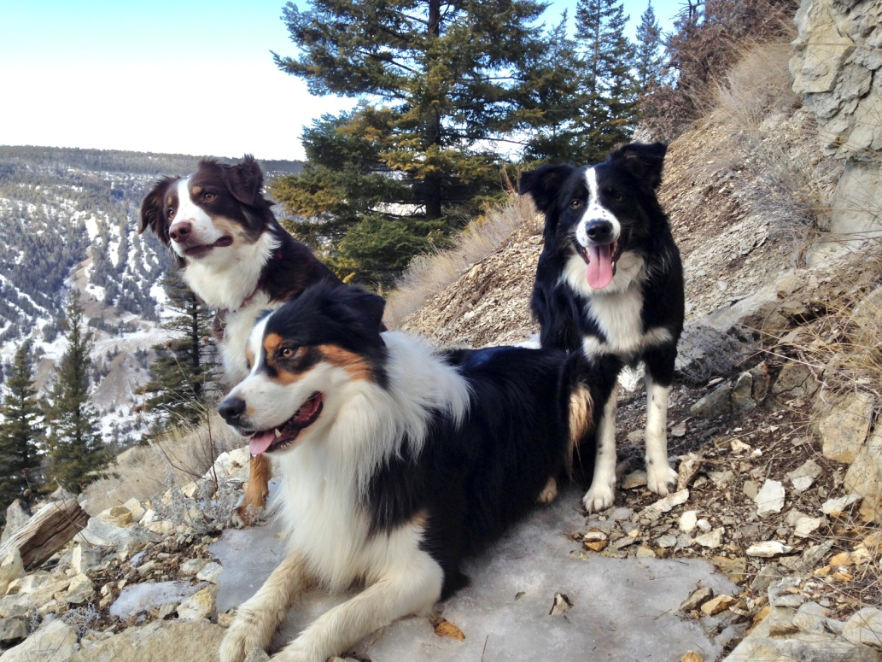
And with so many things to see and do, make sure to stay awhile!

Williams Lake is surrounded by trail-laced hillsides. And with abundant lakes, rivers and mountains nearby, the Cariboo and Chilcotin regions naturally attract outdoor enthusiasts.

Animals & Things to Do Images (scroll through)

Amazing mountain biking, hiking and trail running await. Explore Farwell Canyon and take in the Williams Lake Stampede. Explore the Gold Rush Trail, Barkerville Historic Town and Wells. Visit the nearby historic communities of Horsefly and.

_____________________________________________________________________________________________

